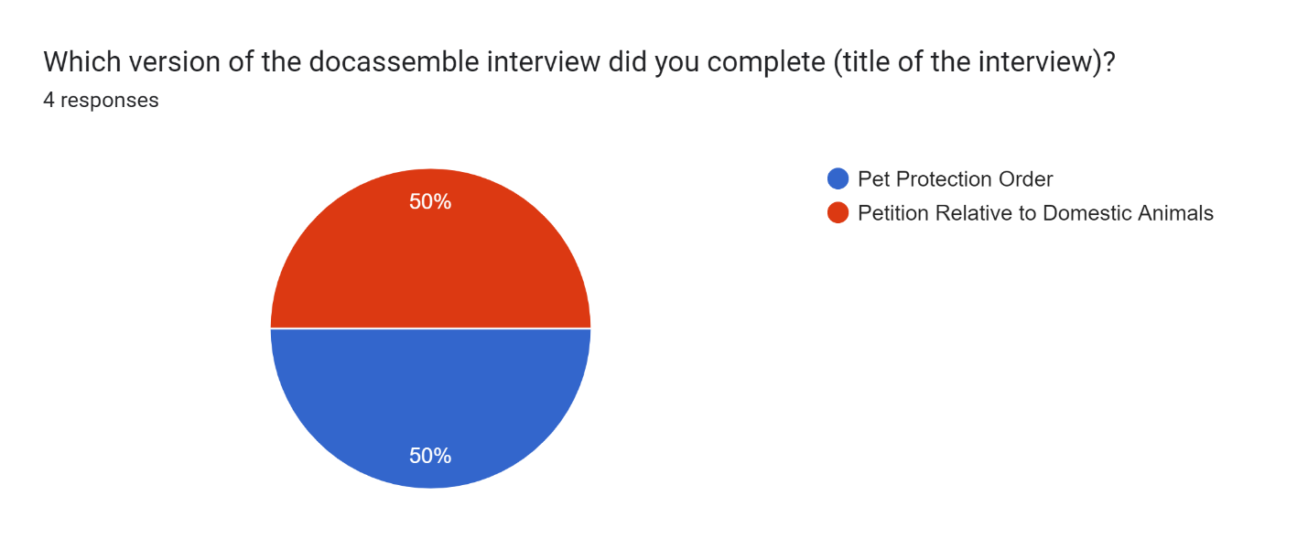

Please provide any suggestions with how to improve the interview.

4 responses

Some of the questions need to be worded more clearly. Question regarding the specific request of the court had a few typos. Informational screens at the start of the interview were helpful, however again more organized screens would be helpful.

Information at the start was helpful, but forgot what type of case met the requirements when answering the question. I don't know if you can do this, but may try to include the information throughout the interview.

Good interview, very easy to understand what was going on.

The questions throughout the interview could be more specific. Some questions were too broad and difficult to understand. Information throughout the interview did help with this.